Question 1- Water Jug Problem



Question 2 – Mars Rover

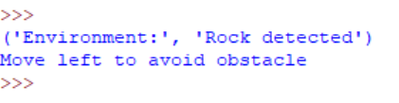

Question 3 - 8 Queen



Question 4 – OLA Cab Booking

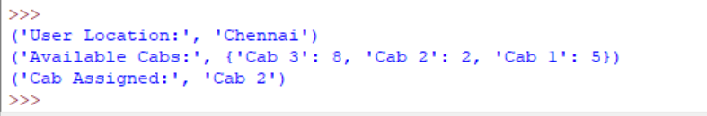

Question 5 – Uniform Cost Search



